**ANALYSIS OF OUR ALGORITHMS WITH DATA SETS**

DATA-1

|  |  |  |
| --- | --- | --- |
| PROCESS | ARRIVAL TIME | BURST TIME |
| P1 | 0 | 8 |
| P2 | 0 | 9 |
| P3 | 0 | 10 |
| P4 | 0 | 6 |

TIME QUANTUM=3

**NRR OUTPUT**

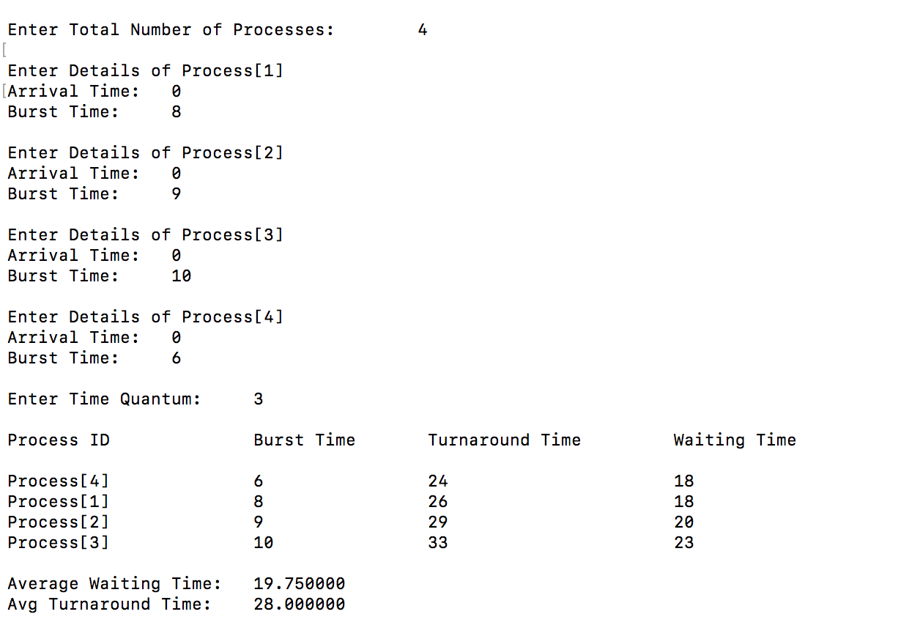

**RR-1 OUTPUT**

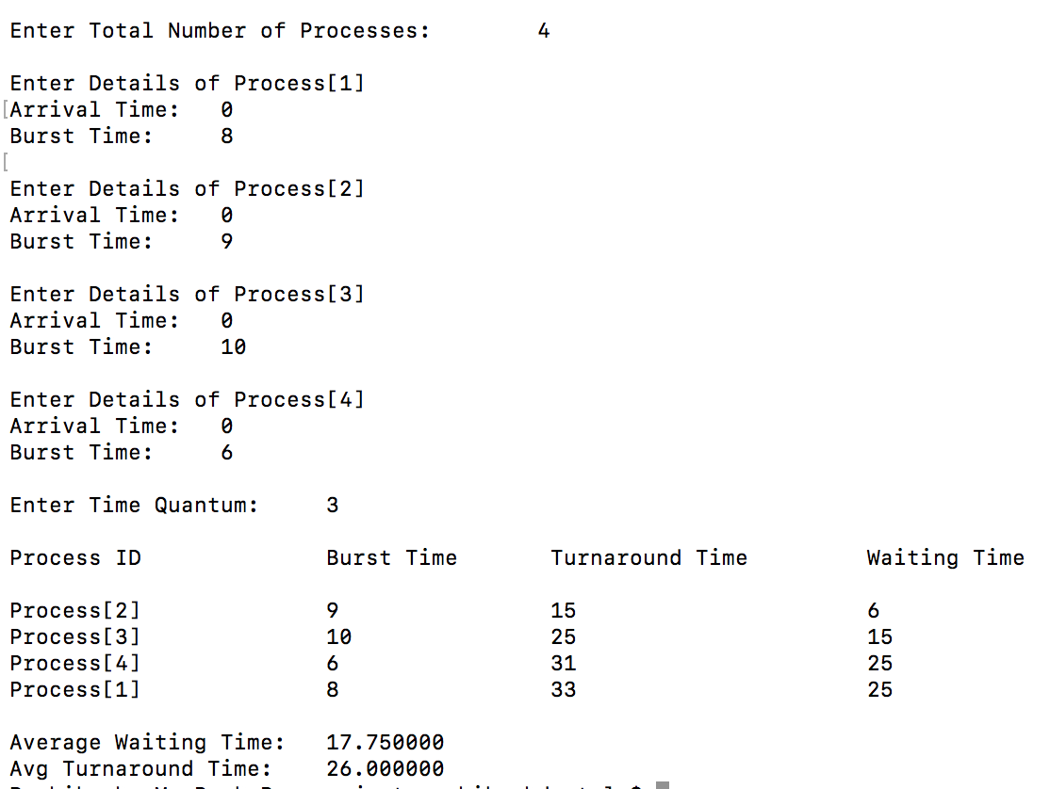

**RR-2 OUTPUT**

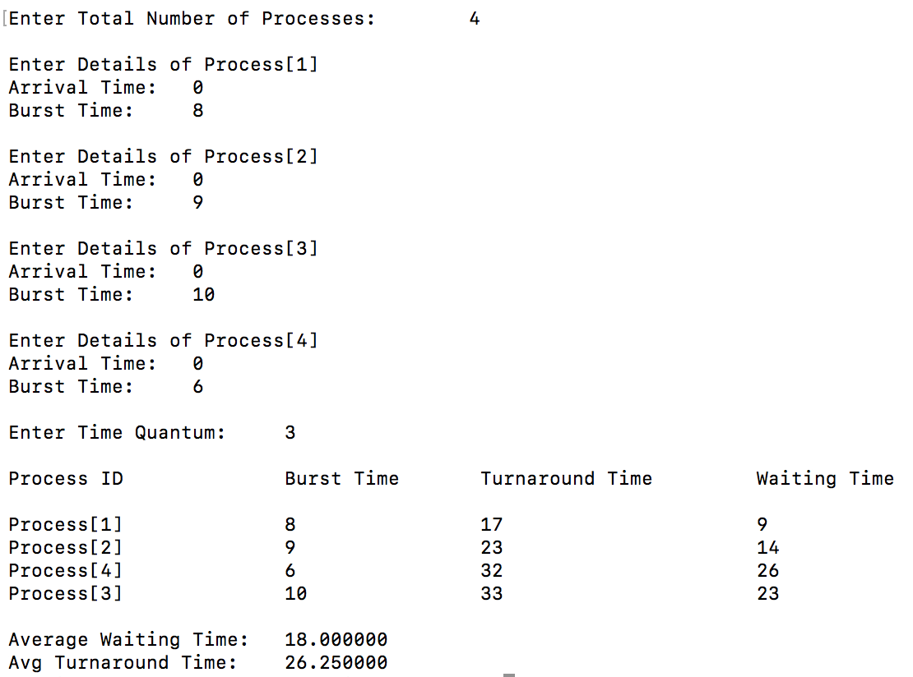

DATA-2

|  |  |  |
| --- | --- | --- |
| PROCESS | ARRIVAL TIME | BURST TIME |
| P1 | 0 | 10 |
| P2 | 1 | 5 |
| P3 | 2 | 7 |
| P4 | 3 | 9 |

TIME QUANTUM =2

**NRR OUTPUT**

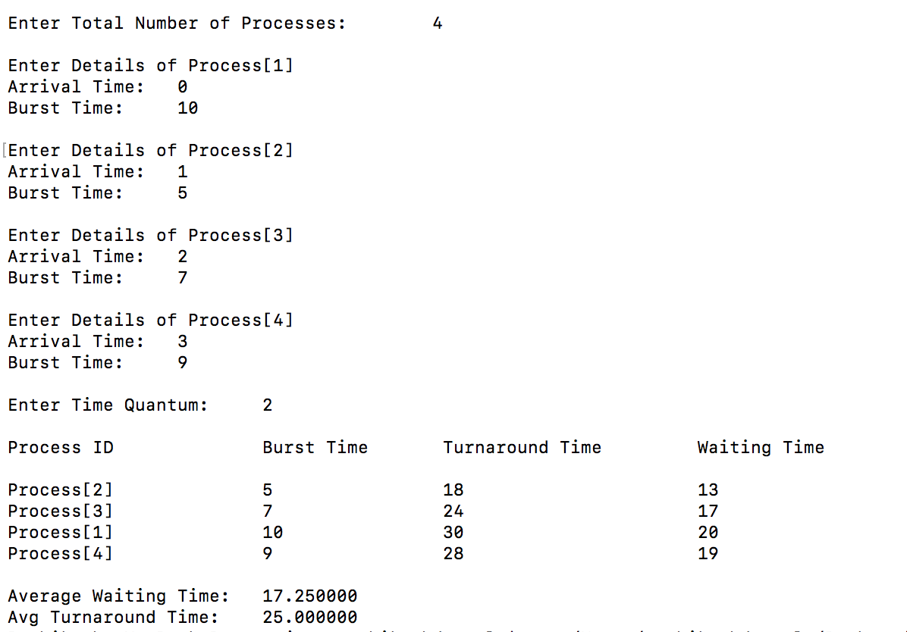

**RR-1 OUTPUT**

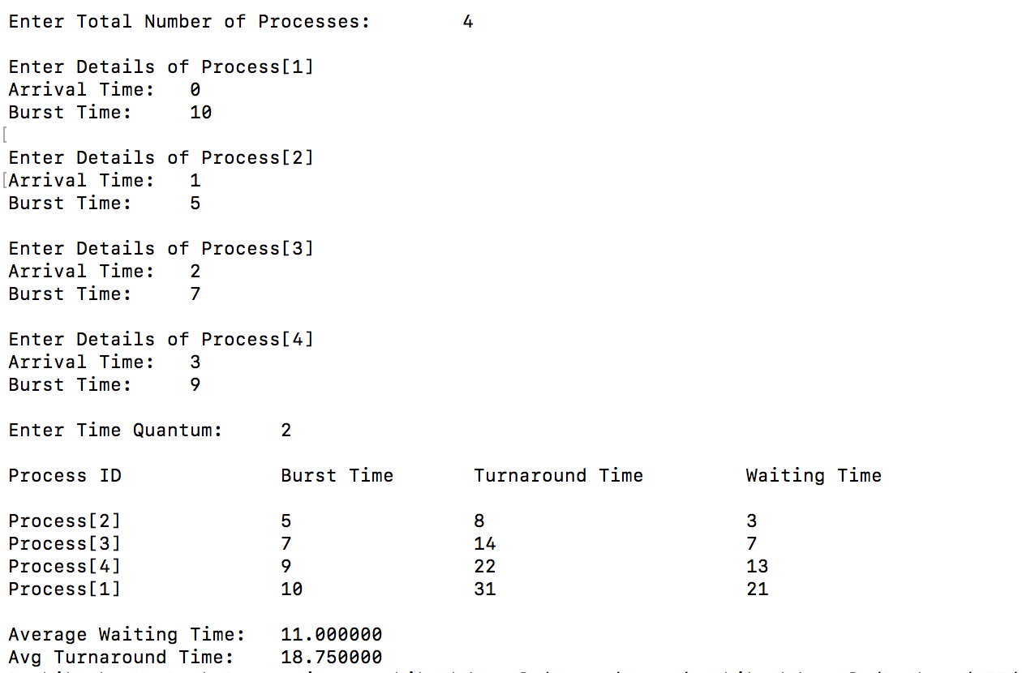

**RR-2 OUTPUT**

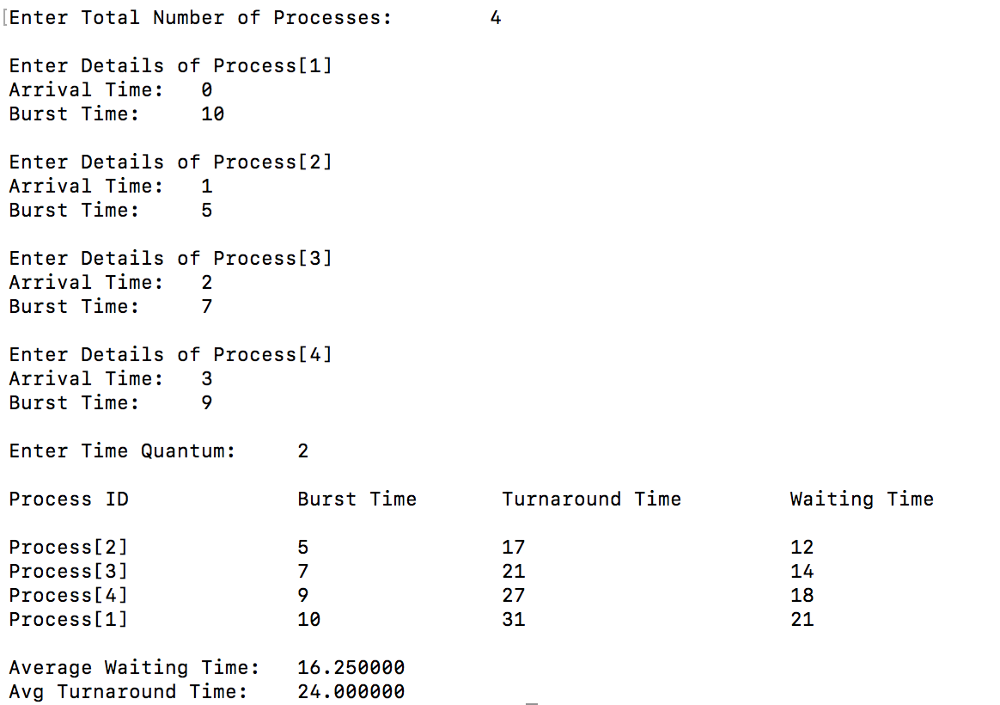

DATA-3

|  |  |  |
| --- | --- | --- |
| PROCESS | ARRIVAL TIME | BURST TIME |
| P1 | 0 | 12 |
| P2 | 0 | 13 |
| P3 | 2 | 10 |
| P4 | 2 | 9 |
| P5 | 3 | 11 |
| P6 | 3 | 7 |
| P7 | 4 | 6 |

TIME QUANTUM=3

**NRR OUTPUT**

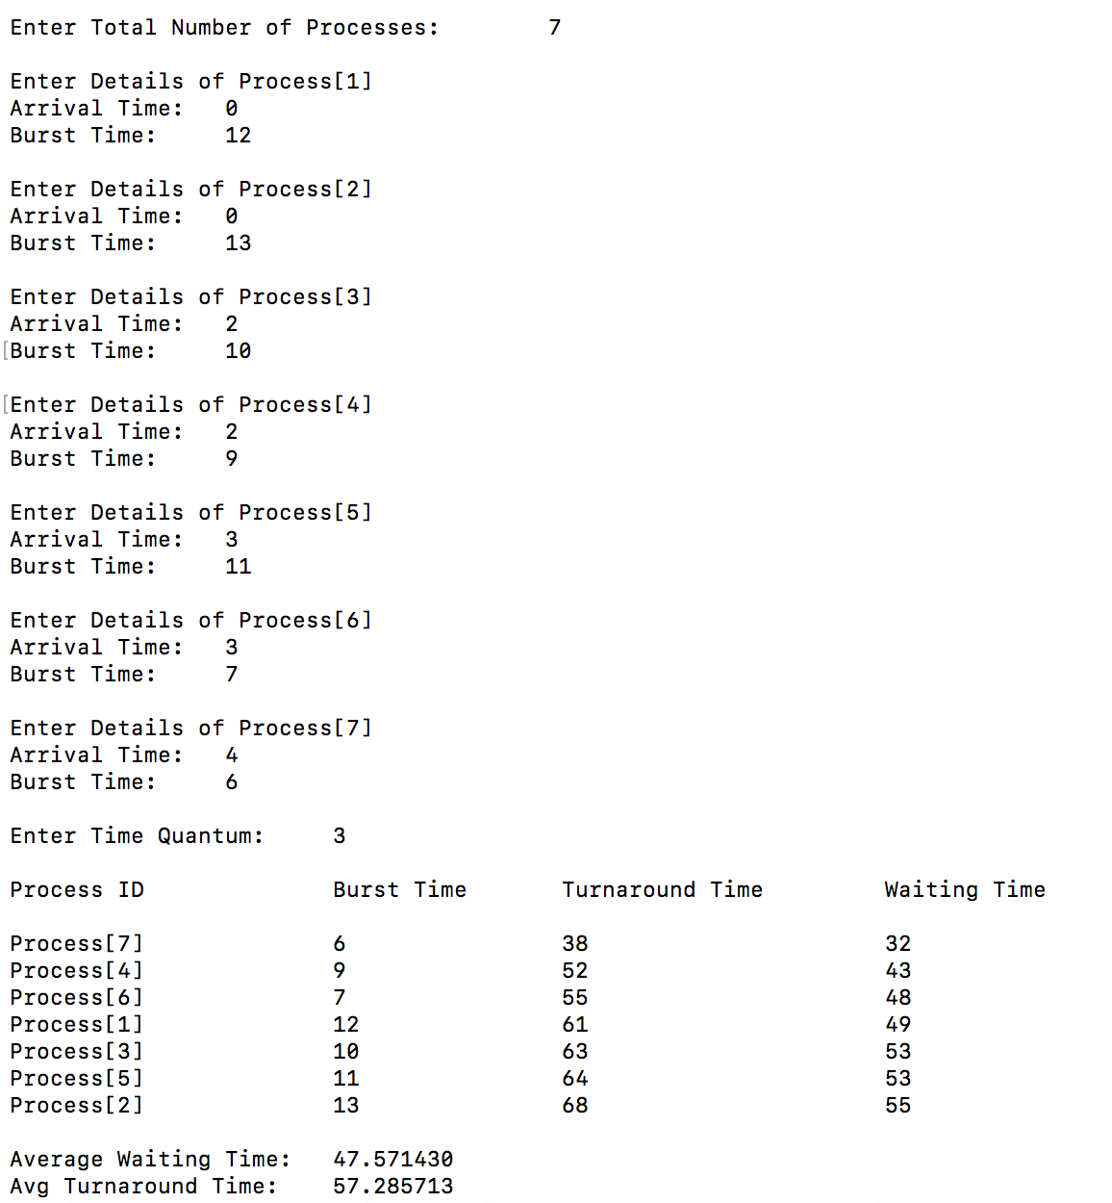

**RR-1 OUTPUT**

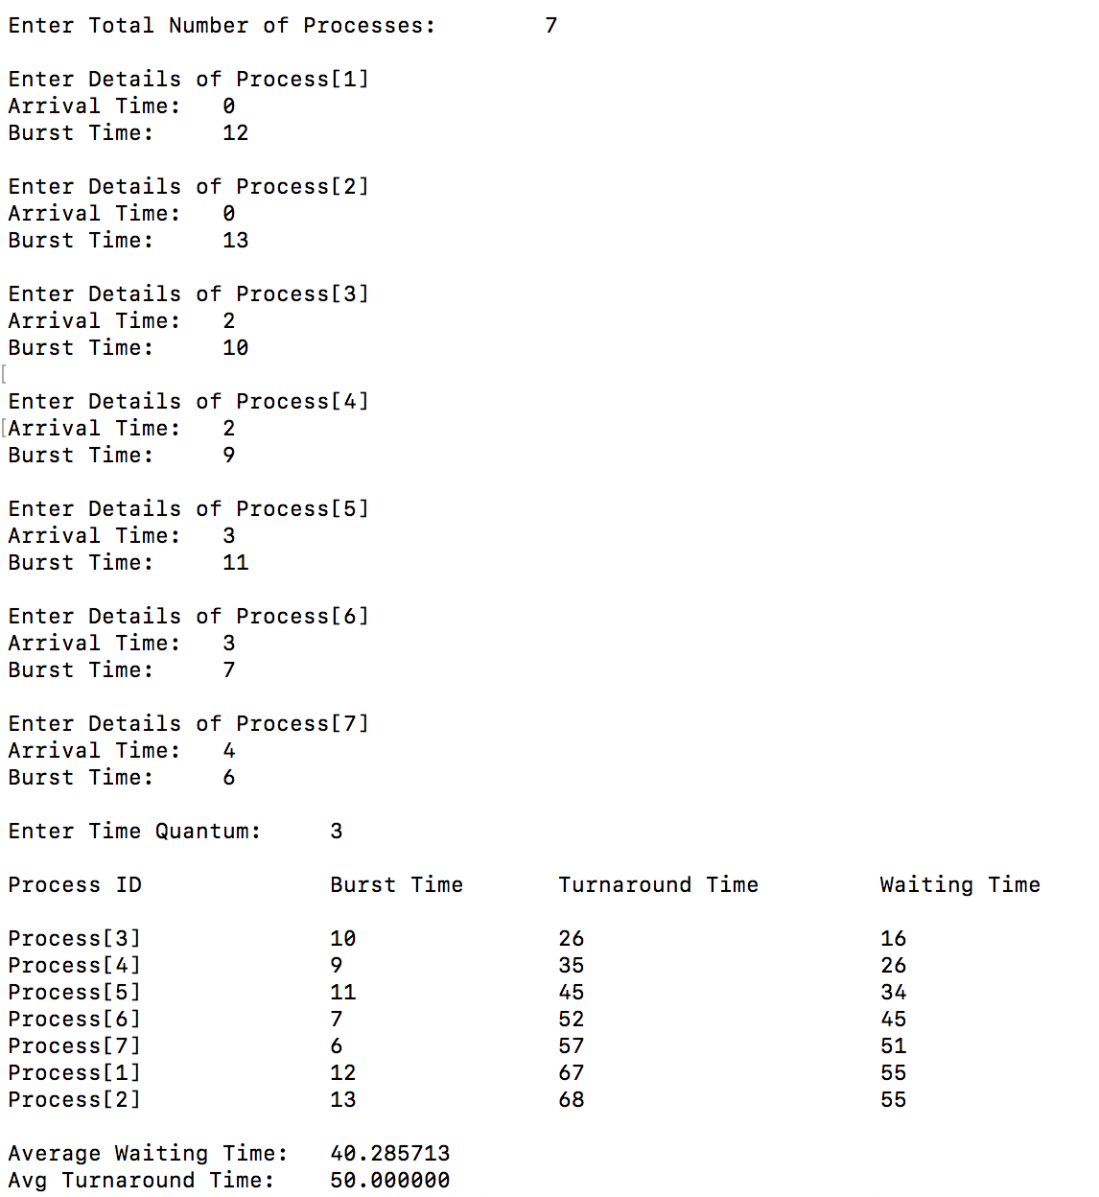

**RR-2 OUTPUT**

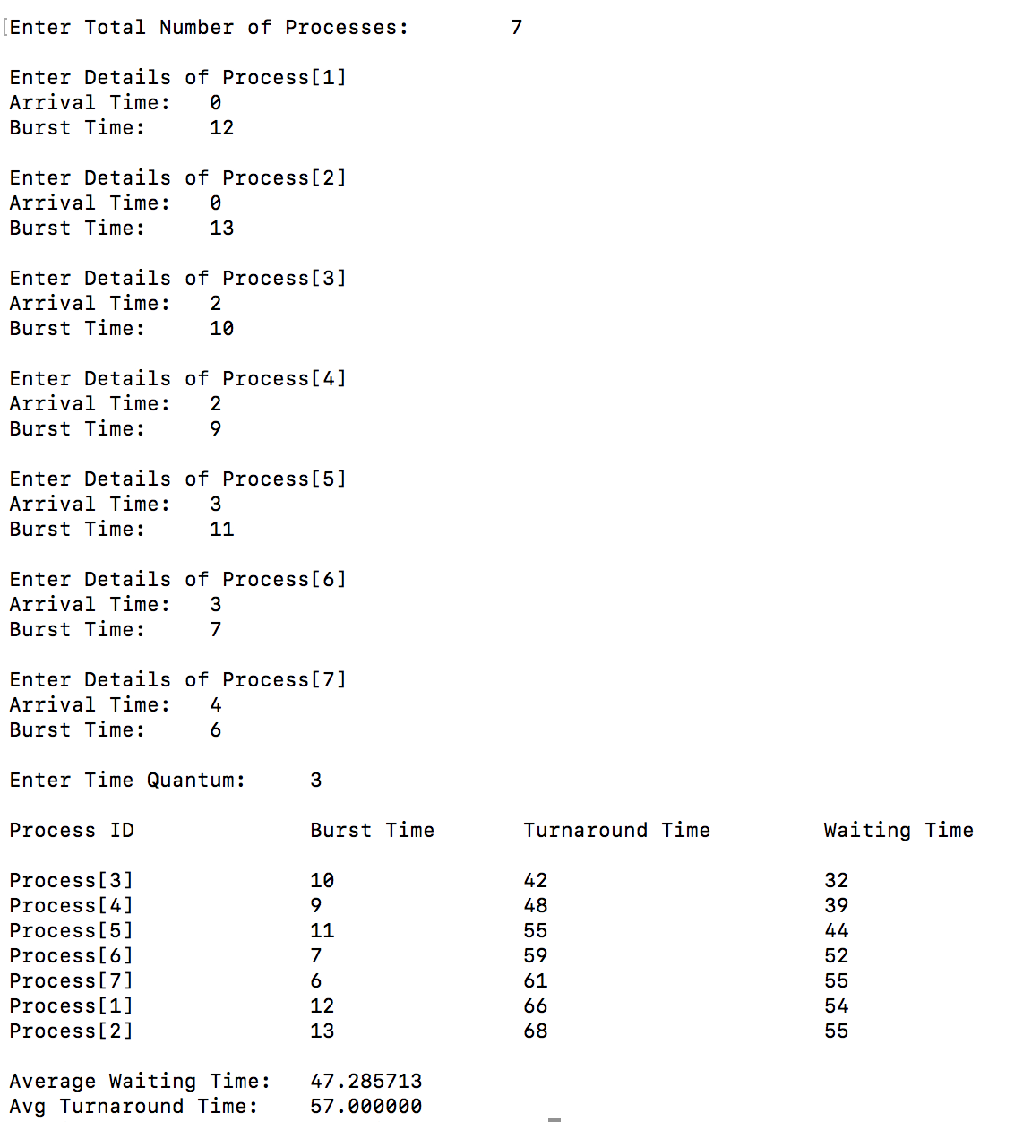

DATA-4

|  |  |  |
| --- | --- | --- |
| PROCESS | ARRIVAL TIME | BURST TIME |
| P1 | 0 | 10 |
| P2 | 0 | 11 |
| P3 | 1 | 7 |
| P4 | 2 | 14 |
| P5 | 3 | 9 |
| P6 | 4 | 8 |

TIME QUANTUM=5

**NRR OUTPUT**

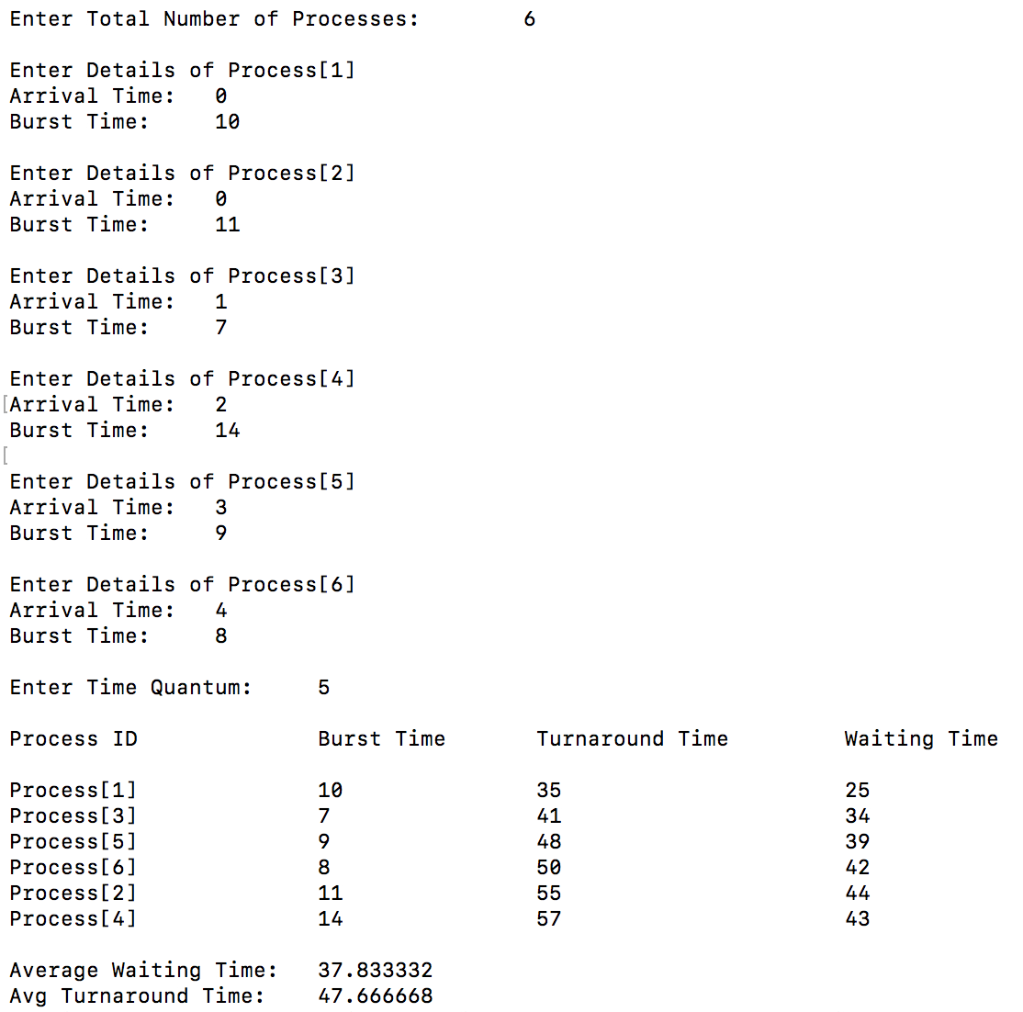

**RR-1 OUTPUT**

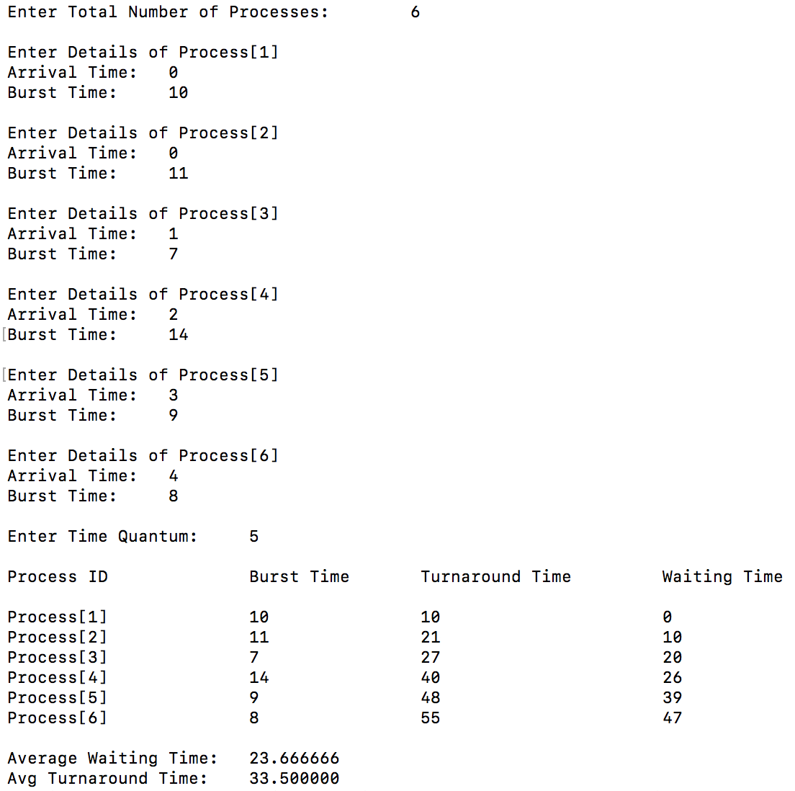

**RR-2 OUTPUT**

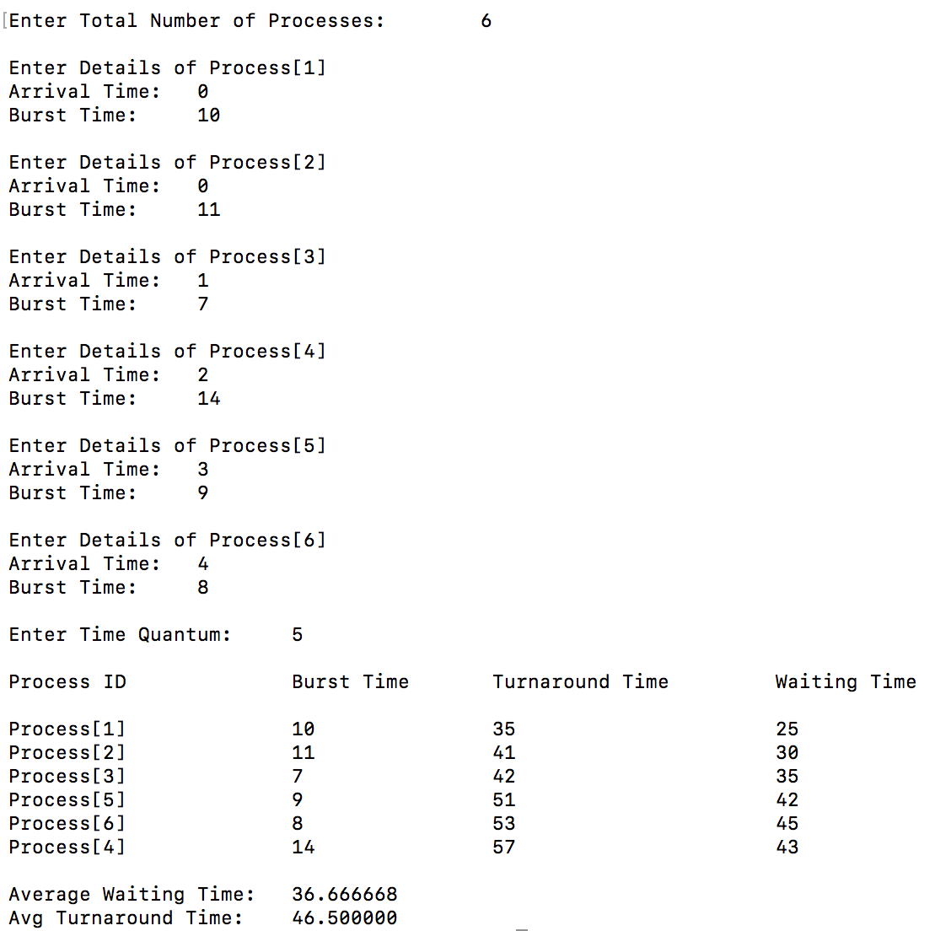

**CONCLUSION**

AVERAGE WAITING TIME

Average Turnaround time